Call: H2020-NMBP-HUBS-2018
Topic: DT-NMBP-02-2018
Funding Scheme: Innovation Action (IA)

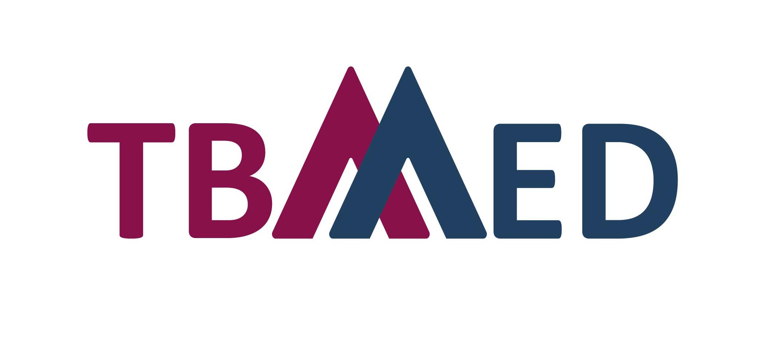

Open Call

Table of Contents
A. Applicant Information 3
Product FEATURES 5
Product INFORMATION 6
Product Description and Design (Maximum four A4 page, not including instructions for use) 6
Device Composition (Maximum three A4 page) 6
Safety and Efficacy of the product 7
Pre-Clinical Validation 7
Clinical Assessment (IF ANY) 7
Risk management 7
Clinical Investigation Documentation 8
Regulatory and licensing status 9
CE Marking Status (if applicable) 9
FDA Marking Status (if applicable) 9
Other Regulatory Bodies (if applicable) 9
CERTIFICATES (PRODUCT and/or company) 10
Inspections/Authorizations/Certifications/Quality Controls 10
B. Project Outline 11
State of the art 11
Technological insight 11
Market scenario 11
Expertise and resources 12
C. Authorization 13
D. Checklist of Attachments 14

Application form

Instructions:
Fill out the information that is applicable to your product, company/institution/sponsor and knowledge. Each applicant may only fill out and submit one application form.

Complete the fields in this questionnaire as applicable.
- Tick or place an X in any of the blocks that are true/applicable.
- Add rows to tables to include requested information. Alternatively, you may attach information in a separate sheet using the same format requested.
- In some cases, it may be required to duplicate rows, copy the section and paste as needed.
- Update the table of contents when completed.
- Please be sure to correctly provide the information requested

SUBMISSION QUESTIONNAIRE

SHORT TITLE of Project Proposal: …………………………………………………

Applicant Information
The information in this questionnaire will be shared with the members of the Selection Board for the purpose of assessing the applications. You will be asked to confirm that you are okay with this at the end of the application form under “AUTHORIZATION”.

Questionnaire Submission Date (DD/MM/YYYY)
Company Name
Physical address
Postal address
Country
Telephone number
Fax
Website
Email
Type of service required |  | To perform a clinical investigation (Proof of Concept) in the Basque Country (TRL-6)  To perform a multinational clinical investigation in at least two of the ECRIN country members
Power source |  | Active Medical Device  Non-Active Medical Device |  | Stand-alone software as a Medical Device
Invasiveness |  | Surgically Invasive Medical Device  Implantable Medical Device |  | Non-invasive Medical Device
Duration of contact with the patient |  | Transient contact (less than 60 minutes)  Short-term contact (up to 30 days)  Long-term contact (more than 30 days)
Medical area in which the medical device could be classified |  | Ophthalmology  Orthopaedics  Wound management  Neurology |  | Drug-delivery  Cardiology  Other (please specify) ___________
Impact |  | Society  Patients  Professionals  Health System sustainability |  | Image and/or prestige  Economic return for the system  Business sector
Comments:

Provide contact information for each of the following:
 | Queries with regard to the application form (such as Principal Investigator) |  | Technical Specifications and Quality Assurance |  | General Inquiries
Name:
Telephone:
Cell phone:
E-mail:

Product FEATURES
Brand name (if any)
Website (if any)
Generic name of the product (if any)
In case of medical device, please add the EU classification | Class I Class I (Special function)  Class IIa Class IIb  Class III Not assessed yet
State of the development process (approximate TRL - Technology Readiness Level) More details under are available here. | 5-6 7-9
Intended Use (300 characters) | State the intended use of the device and/or provide a general description of the disease or condition that the device will diagnose, treat, prevent, cure or mitigate.
Target Population (300 characters) | Describe the target patient population for which the device is intended. Specify if the device is for pediatric use.
 | Pediatric use | Not for pediatric use
Time to be introduced in the market | ≥ 4 years 1-3 years < 1 year Adaptive pathway
Competitors | Similar products/technologies/services are close to the market.  Similar products/technologies/services are far from entering the market.  Similar products/technologies/services have not been identified yet.
Feasibility of the project | The company has not developed a business plan yet.  The company has developed a business plan.  The company developed a business plan and also has a financial plan.
Use | Identify if the device is intended for single use or is reusable
 | Single Use Reusable

Product INFORMATION

Product Description and Design (Maximum four A4 page, not including instructions for use)
Attach copies of the design drawings, diagrams, photos, if applicable.
Provide a general description on design, characteristics and performance of the medical device that you have designed.
Provide instructions for use

Device Composition (Maximum three A4 page)
Provide a summary of the composition of the device, including at minimum, the material specification and/or chemical composition of the materials that have direct or indirect contact with the user/patient.
Indication of biological material or derivate used in the medical device.
Biological material or derivate is used in the medical device. (If yes, specify origin (human, animal, recombinant or fermentation products or any other biological material; source (blood, bone, heart any other tissue or cells) and the intended reason for its presence and if applicable, its primary mode of action.

Not applicable

Safety and Efficacy of the product

Pre-Clinical Validation
Proper addressing of this criteria and fulfillment is mandatory.
Provide the biological plan evaluation according to the ISO 10993-1 and summarize the outcome of the biological plan evaluation.
Provide the list of applicable standards for the medical device and a summary justifying the compliance to those standards

Clinical Assessment (IF ANY)
Provide a summary of the clinical evaluation of the product, if applicable.
Not applicable

Risk management
Attach a copy of the Results of risk management, per product medical device.
Provide a summary of the risks identified during the risk analysis process (ISO 14971) and how these risks have been controlled to an acceptable level. The results of the risk analysis should provide a conclusion with evidence that remaining risks are acceptable when compared to their benefits. When a standard is followed in the risk assessment, describe the standard.
Not applicable

Clinical Investigation Documentation
Indicate the progress of elaborating documentation related to the device for the clinical investigation in case of any.
In case the manufacturer has started to develop the clinical investigation dossier, please indicate the progress of development of essential documents related to clinical investigation

Clinical Investigation Protocol | 0% | 25% | 50% | 75% | 100%
Investigator’s Brochure | 0% | 25% | 50% | 75% | 100%

Not applicable

Regulatory and licensing status

CE Marking Status (if applicable)
Provide a copy of the relevant CE Mark certificate for each applicable variant, if applicable.
Product is CE Marked
Product is not CE Marked
Product submitted for CE Mark evaluation, but is still to be approved.
Date of Submission (DD/MM/YYYY):
Comments:

FDA Marking Status (if applicable)
Provide a copy of the relevant FDA Mark certificate for each applicable variant, if applicable.
Product is approved by the US FDA: (specify authorization number)
PMA#
510K#
Other (Specify):

Product submitted for US FDA evaluation. Waiting for registration approval.
Date of Submission (DD/MM/YYYY):
Comments:

Other Regulatory Bodies (if applicable)
Provide a copy of the relevant Regulatory´s certificate, if applicable.
Comments:

Not applicable

CERTIFICATES (PRODUCT and/or company)
Tick or place an X here if there is no information available

Inspections/Authorizations/Certifications/Quality Controls
Add rows to the table if you need to include more information.
Type of document (Inspections/ Authorizations/ Certifications/ Quality Controls) | Authority | Certificate No. | Date Issued  (DD/MM/YYYY) | Valid until  (DD/MM/YYYY)

SPECIFIC DETAILS OF THE PROJECT

Project Outline

State of the art
Approximately three A4 pages
Describe scientific and methodology features that justify the development of the product.
Describe the clinical indication and the solution proposed by the medical device
Describe the advantages and impact (support needs that are not currently addressed, important advance in the field, interest of the clinicians on the medical device) of the medical device in the health system

Technological insight
Technological Development Envisaged (approximately five A4 pages)
Describe the state-of-the-art of the technology and the technological developments envisaged.
Describe the current state of development, including needed tests identified such as biocompatibility
Describe the needs identified to progress in the development of the medical device
Describe the concrete results expected at the end of the project in this call (design of the Clinical Proof of Concept or Clinical Investigation, process, etc.)
Describe the expected support for the medical device coming from the TBMED partners in this call

Market scenario
Market Application and Exploitation (approximately four A4 pages)
What is the market envisaged (description)?
What is the estimated market size and expected market share?
Describe the position of the partners in the market(s)?
What is the status of the competition in the market(s)?
What is the plan to bring the product to the market?
What are the revenues foreseen at the end of the first year?

Expertise and resources
Approximately four A4 pages
Describe your expertise and core business.
What is the total number of Full-Time Equivalents working on R&D and regulatory affairs? (figures).
Do you have previous experiences taking part in a clinical Proof of Concept or Pivotal clinical investigation?? (Yes/No). Please justify.
Describe your managerial expertise with regard to the market addressed.
Does the company have enough resources to complete the innovation cycle of the medical device development and achieve bringing it to the market? (Yes/No). Please justify accordingly to your business plan or possible European/national aids
Does the company have pre-identified clinical investigators?
What is the manufacturing capacity of the medical devices (i.e. manufacturing rate/day)?
Did the company start to elaborate documentation for the clinical investigation? Please justify

Authorization

Authorization for sharing information
I, the undersigned [ENTER FULL NAME], CERTIFY that the information stated above is true, correct and complete to the best of my knowledge. Likewise, I confirm that the company has no objection to the information contained herein being shared with the Selection Board.

Name |  | Signature |  | Date (DD/MM/YYYY)
Full title/Position |  | Company name

Checklist of Attachments

Product Information
Copy of design drawings, diagrams, photos
Instructions for Use
Flow diagram and brief narrative describing the manufacturing and control process of this product with relevant parameters.

Pre-clinical Assessment

Biological Plan Evaluation
List of applicable standards

Safety and Efficacy and/or Therapeutic Equivalence (if any)
Summary of Clinical Evaluation Report

Risk Management (if any)
Copy of results of risk management, per medical device

Regulatory and Licensing Status (if any)
CE mark Certificate
FDA mark Certificate
Other regulatory bodies

Certificates (if any)
Recent/valid system certificates (ISO 9001, ISO 13485, other)

Project Outline
State of the art
Technological insight
Expertise and resources
Market scenario

Authorization
Authorization to share information signed

Annexes
Please specify: ______________________
Please specify: ______________________
Please specify: ______________________

Please review the call for more details about the support that each service offers.
ECRIN members and observers: Czech Republic, France, Germany, Hungary, Ireland, Italy, Norway, Poland, Portugal, Slovakia, Spain, Switzerland
When necessary, more information could be asked to complete the evaluation.
This information is optional, it is not mandatory to provide the information requested.
When necessary, more information could be asked to complete the assessment
https://www.ansm.sante.fr/var/ansm_site/storage/original/application/31ab693508ee477f4d3c201c2d888330.pdf

